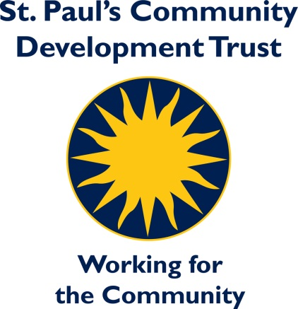

**Job Description**

**Job Title**: Compliance and Facilities Manager

**Department:** Support Services

**Salary Scale:** £37,198 - £42,432pa (pro rata £29,765 - £33,946pa)

**Hours of work:** 30hrs per week (days/times to be agreed)

**Contract Term:** Subject to a 6 month Probationary Period

**Base:** St Paul’s Trust, Balsall Heath, Birmingham

All staff employed by the Trust have an individual responsibility for promoting and safeguarding the welfare of the children/young people and vulnerable adults that they are responsible for or meet.

**Job Purpose:**

**A member of the Senior Management Team, responsible for driving and promoting a culture of health and safety compliance across the Trust. Embedding risk management in relation to legislation, regulation, policies, and contractual obligations. Overseeing Health and Safety, IT and Facilities Management.**

**Main Responsibilities:**

1. Develop/review, implement and maintain compliance policies and procedures relating to Health and Safety.
2. Conduct regular audits and assessments to ensure the Trust is complying with all applicable laws and regulations in relation to Health and Safety.
3. Provide a robust and clear practical interpretation of health and safety legislation, closely with other departments to ensure compliance in their areas of responsibility.
4. Oversee the Trust’s IT requirements ensuring delivery of an effective service to enable high quality provision.
5. Developing systems and procedures to ensure compliance of Data Protection legislation, including management of site security and CCTV.
6. Investigate any compliance violations and take appropriate corrective actions.
7. Engaging with and supporting the embedding of the corporate risk management framework.
8. Supporting the development and implementation of the Business Continuity Plan.
9. Oversee the management of the facilities service and maintenance contracts, achieving value for money.
10. Ensure an agile and responsive internal facilities and maintenance service, developing high standards to allow departments to deliver their core activities across our sites.
11. Ensure arrangements are in place for responding to out of hours emergencies, including alarm call-outs.
12. Manage identified budgets, ensuring that financial controls are in place and observed.
13. Support the development of service standards and implement along with monitoring processes.
14. Develop, record, and report upon performance within own service area.
15. Write and present reports to SMT and the Governance arrangements of the Trust.
16. Support with the development and implementation of the strategic and annual business plans
17. Manage staff working in the areas of facilities with the delegation of supervision where appropriate.
18. To demonstrate a commitment to Equality, Diversity and Inclusion.
19. To participate in the supervision process including the Probationary Review.
20. Contribute to effective systems for management of staff performance, incorporating supervision, performance reviews and targets
21. Assist in the development of Trust policies and procedures.
22. To undertake personal professional development and training as appropriate.
23. To promote and support the wider objectives and values of the Trust, including, assisting with organising and running of community events.
24. Undertake any other duties commensurate with the role and responsibilities of the post as agreed with your Line Manager.
25. To be familiar with and uphold the policies and procedures of the Trust especially those relating to Health and Safety, Equalities, Data Protection and Safeguarding.

# Supervision received: Chief Executive

**Supervision exercised:** Direct reports x 2. Current team of 6 members.

#### **Person Specification**

### Method Of Assessment (MOA)

### A = Application form I = Interview T = Test or Exercise

|  |  |  |  |
| --- | --- | --- | --- |
| CRITERIA | ESSENTIAL | DESIRABLE | MOA |
| **Experience &**  **Knowledge** | Excellent knowledge of legal and regulatory requirements regarding compliance areas of responsibility – health and safety, food standards, environmental, data protection  Experience in developing and implementing compliance policies and procedures  Experience of IT support functions and oversight  Experience and working knowledge of risk management  Experience of planning, developing, monitoring and evaluating services  Understanding and experience of facilities management requirements  Experience of site security/CCTV  Leadership and/or management experience |  | A/I/T  A/I  A/I  A/I  A/I/T  A/I/T  A/I  A/I |
| Skills & Abilities | Ability to lead and motivate staff within own team and across the Trust  Strong organisation, communication, and inter-personal skills  Internal and external customer focus  Strong analytical and problem-solving skills  Ability to manage multiple projects simultaneously and prioritise accordingly  Ability to promote a health and safety compliance culture within the organisation  The ability to prioritise resources effectively, budget setting and management ability  Report writing, business cases, presentations  Research/innovate and implement continuous improvement  Ability to work independently and as part of a team |  | A/I  A/I  I  A/I  A/I  A/I  A/I  A/I  A/I  A/I |
| **Qualifications & Training** | Good standard of English and Maths  IOSH – Managing Safely  Knowledge of COSHH system requirements  Willingness to undertake training | NEBOSH  Member of IOSH  Facilities Management qualification | A  A  A  I |
| **Equalities** | Understanding of, and commitment to equality, diversity and inclusion and the ability to apply this |  | A/I |
| **Further requirements** | It is essential that all candidates are deemed suitable to work with children and/or vulnerable people. Enhanced DBS check required |  |  |